**Day-22 practice(10/09/2024)**

**Installation process of Terraform**

1. **Open chrome and search for terraform download**
2. **Open this link** [**https://developer.hashicorp.com/terraform/install**](https://developer.hashicorp.com/terraform/install)
3. **Go to windows and select 386.zip file** [**https://releases.hashicorp.com/terraform/1.9.5/terraform_1.9.5_windows_386.zip**](https://releases.hashicorp.com/terraform/1.9.5/terraform_1.9.5_windows_386.zip)

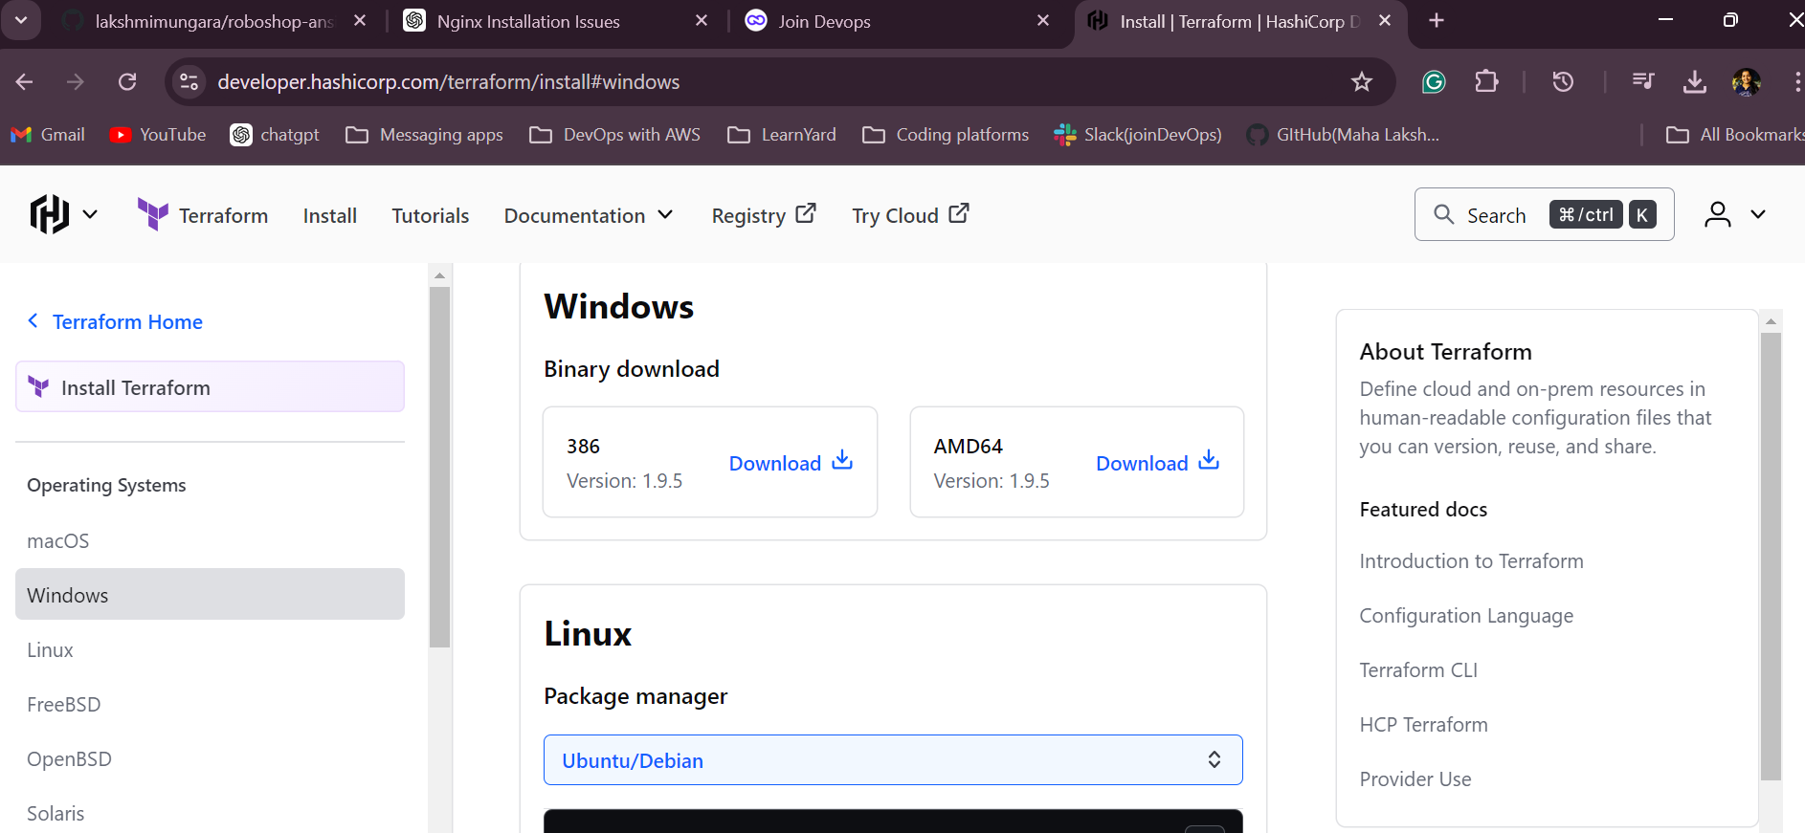

1. **Create a new folder in C-drive or D-drive ex: softwares**
2. **Copy the zip file into it and extract it**
3. **And keep terraform.exe file in the softwares folder**

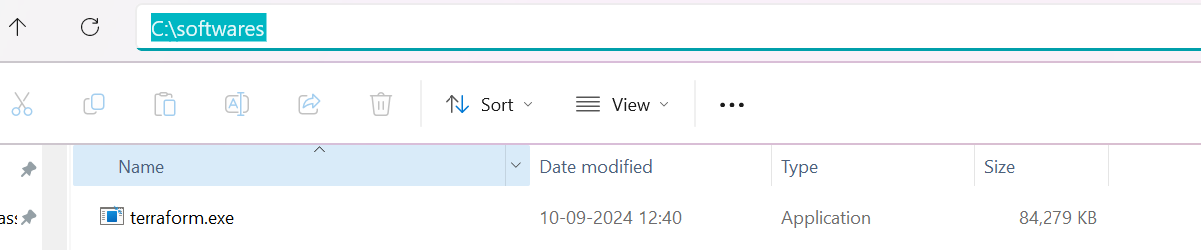

1. **Open the environment variables**
2. **Copy the path of terraform.exe file**

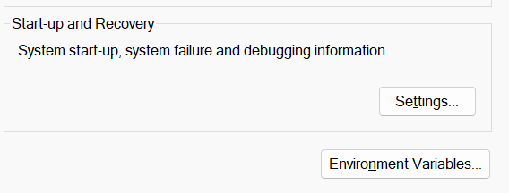

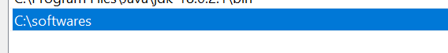

1. **Open GitBash and enter terraform**

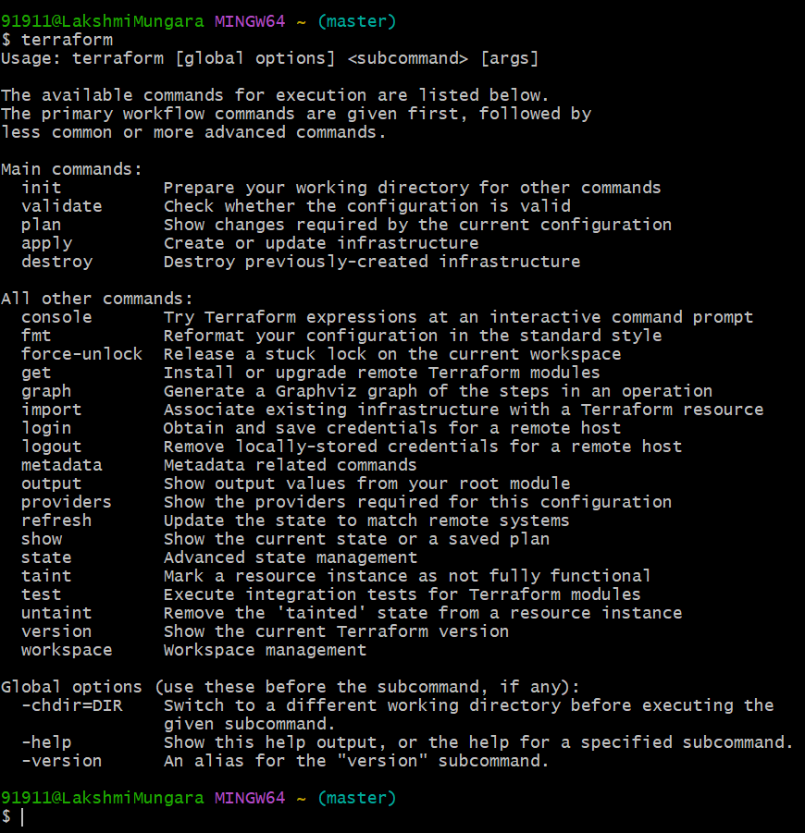

1. **Open chrome and search for aws command line installation**
2. **Click on the first link and select for windows**
3. [**https://awscli.amazonaws.com/AWSCLIV2.msi**](https://awscli.amazonaws.com/AWSCLIV2.msi) **here is the link to download command line**

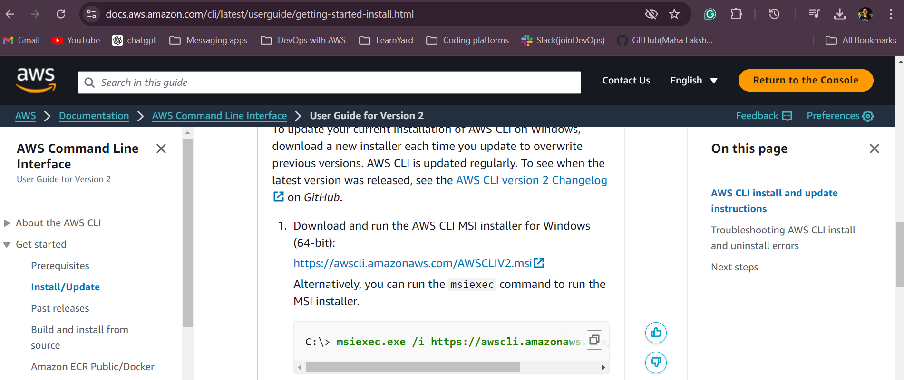

1. **Now, create one repository – terraform**

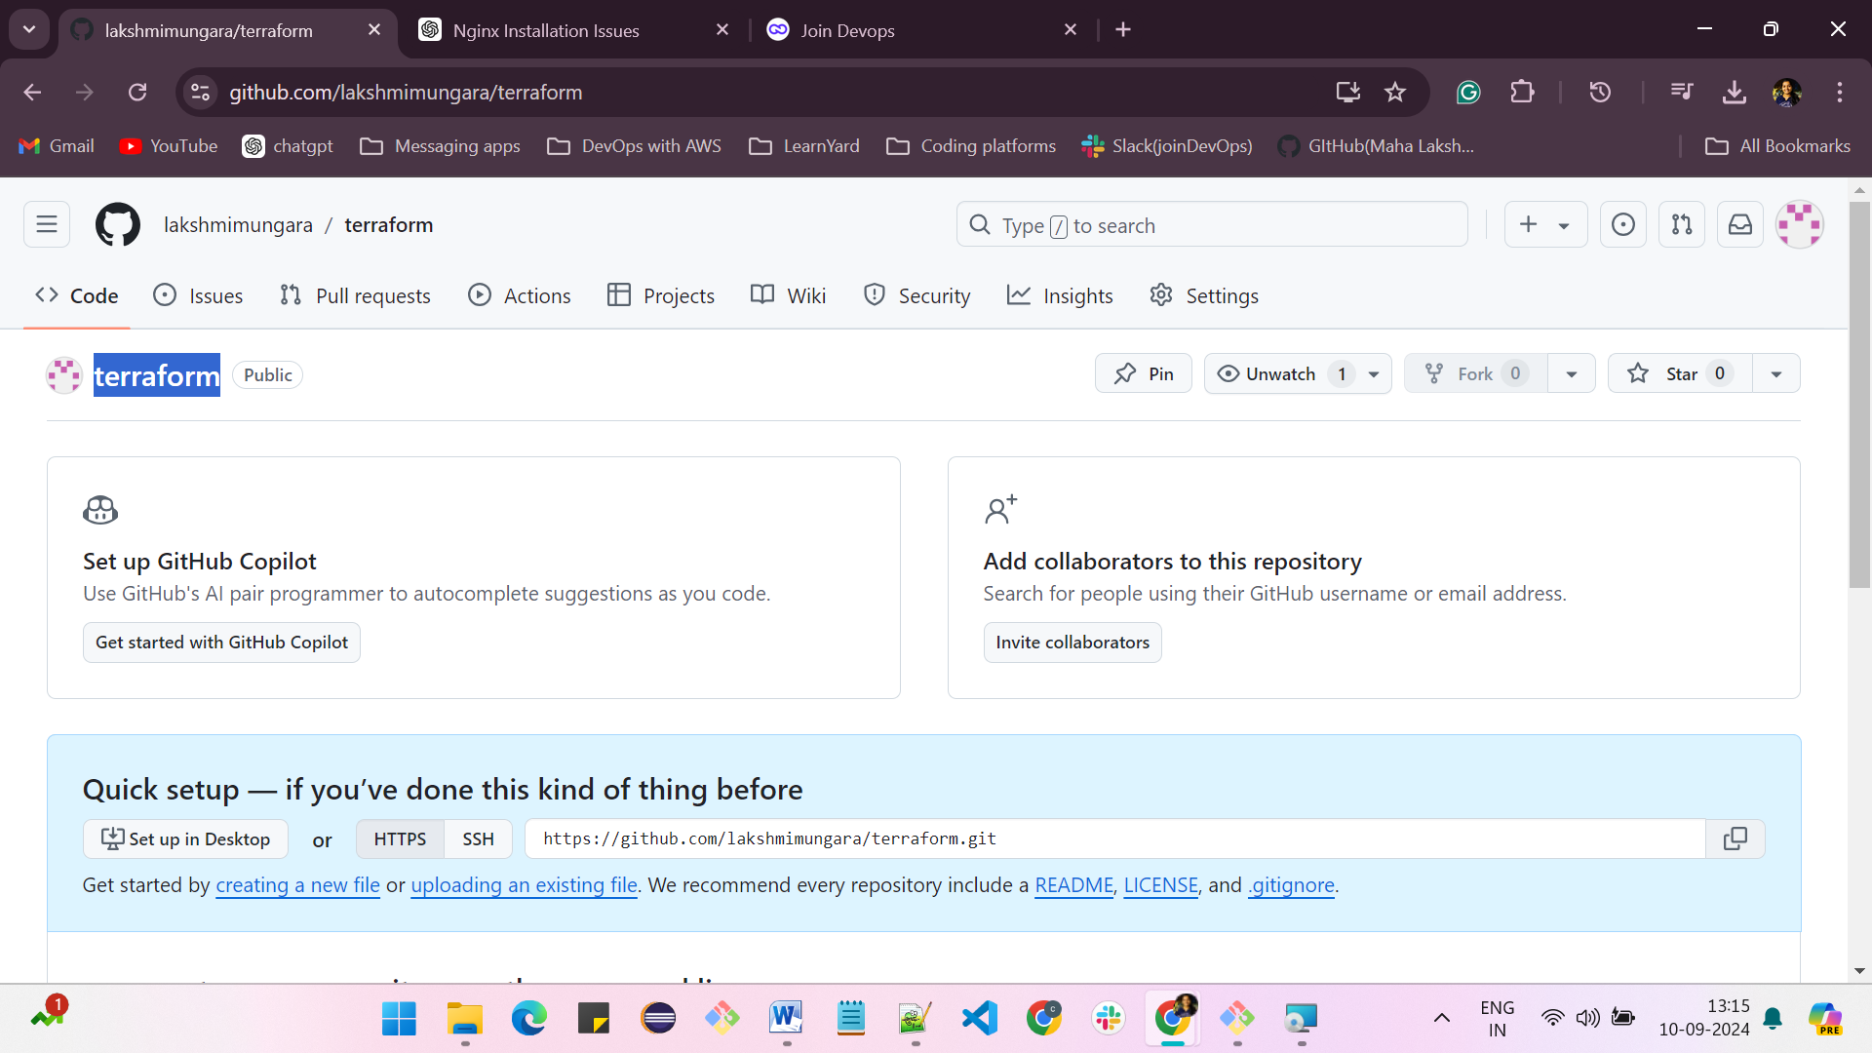

1. **Clone the repository into the gitbash**

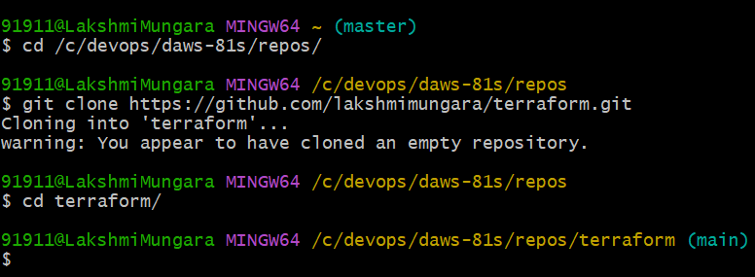

1. **Copy the AWS provider at** [**https://registry.terraform.io/providers/hashicorp/aws/latest**](https://registry.terraform.io/providers/hashicorp/aws/latest)

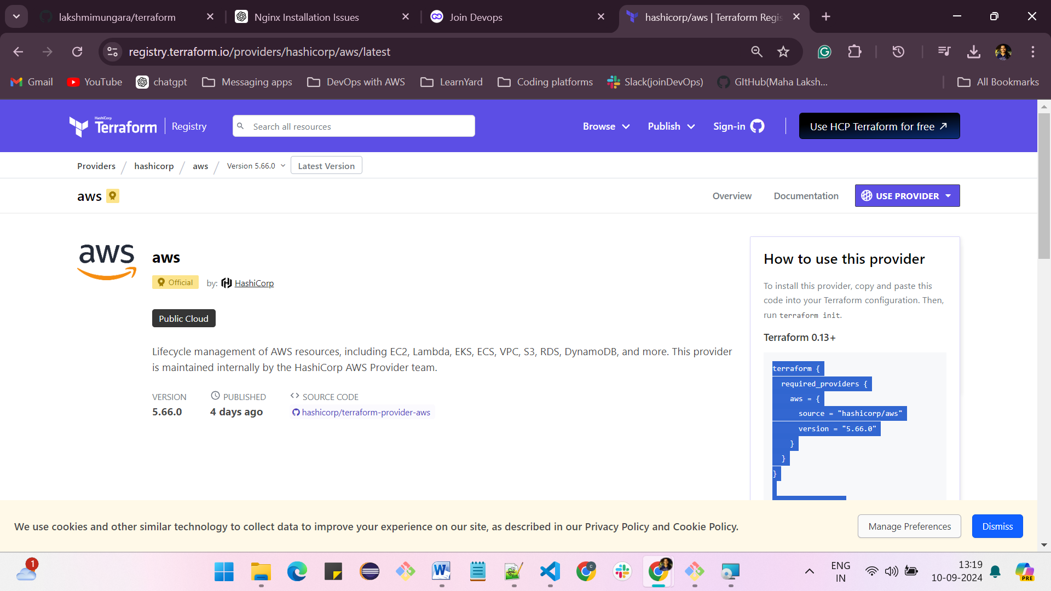

**Create an IAM user and create the access key**

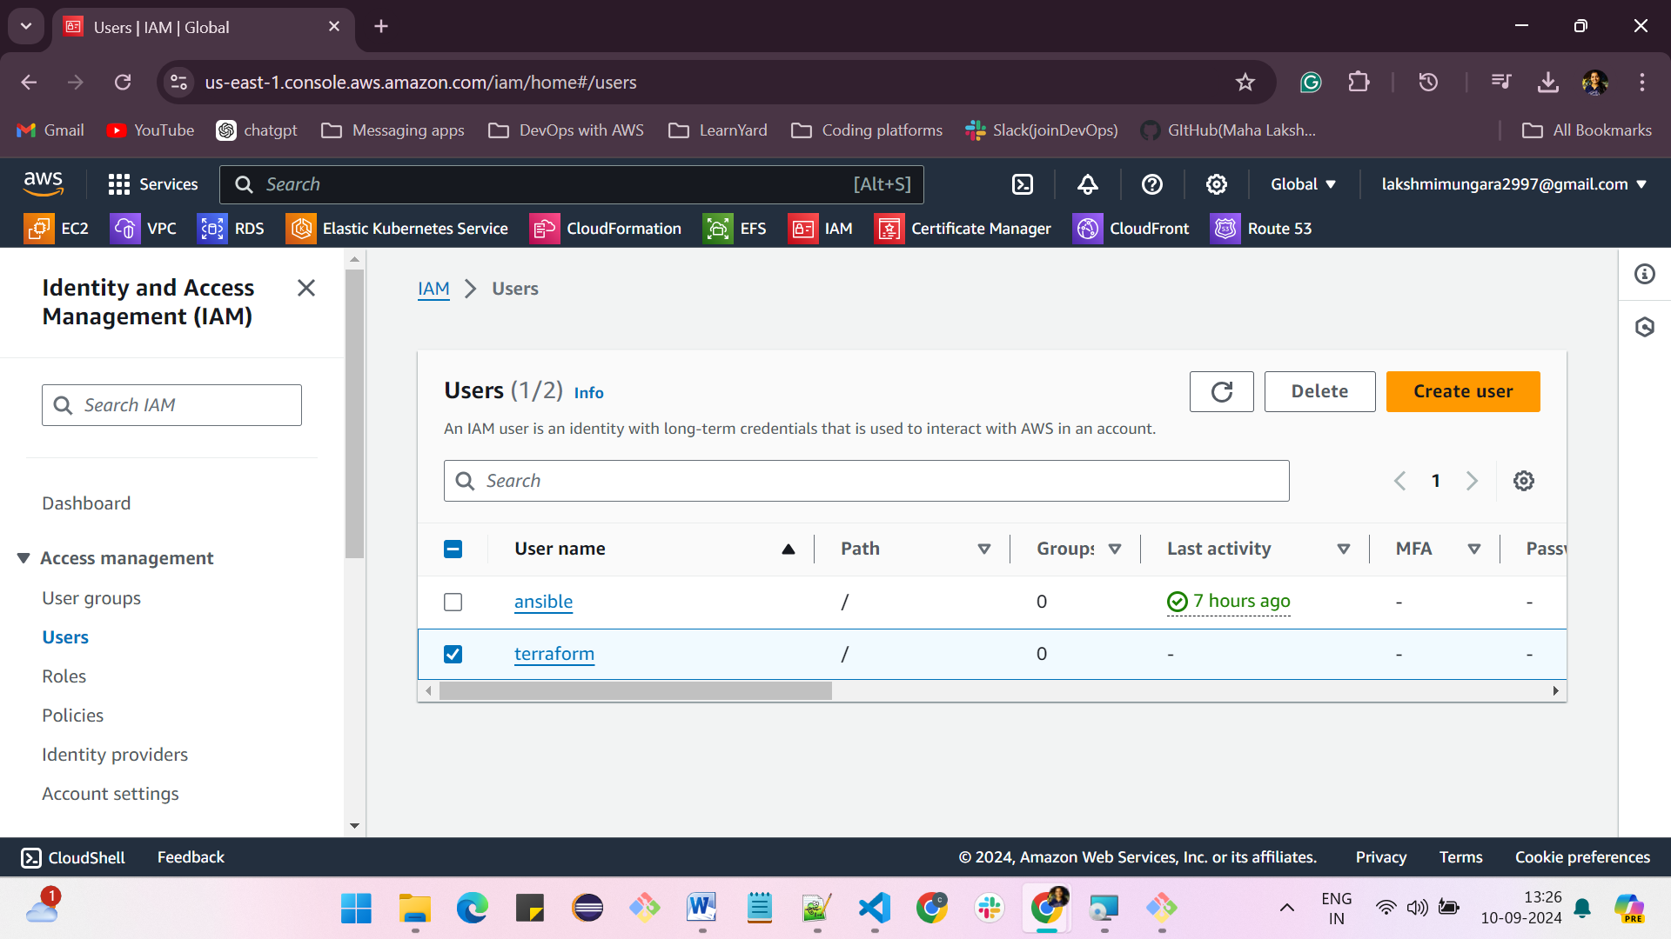

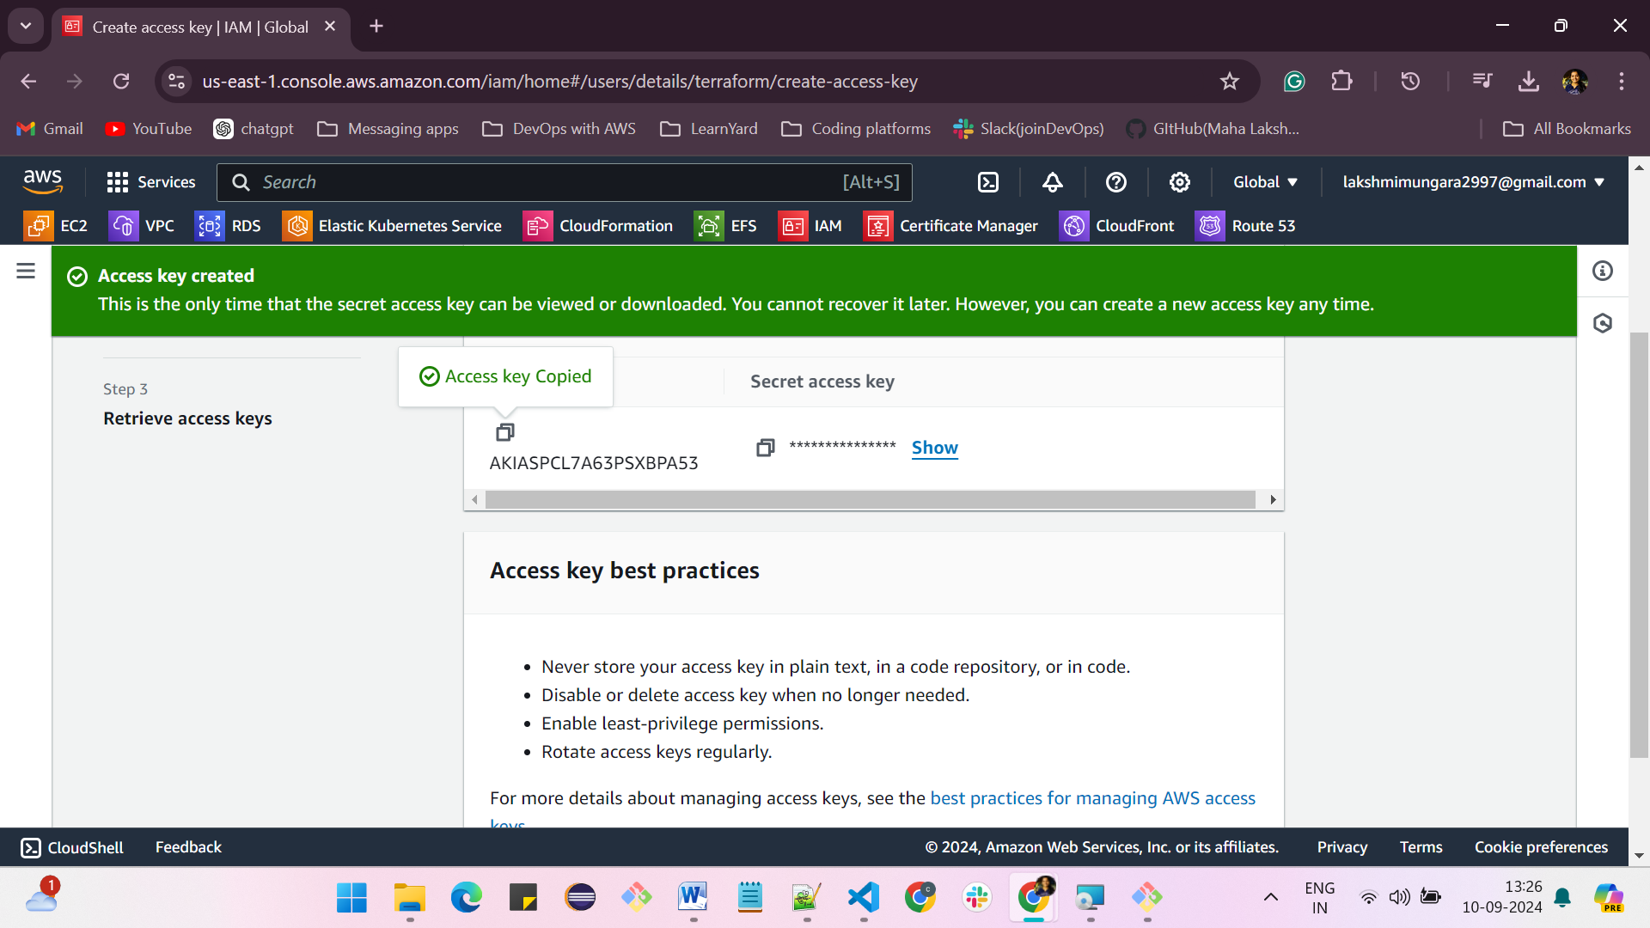

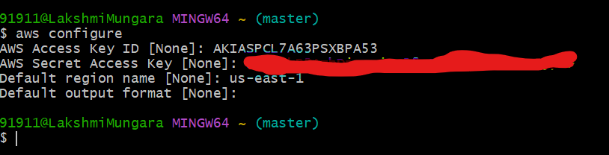

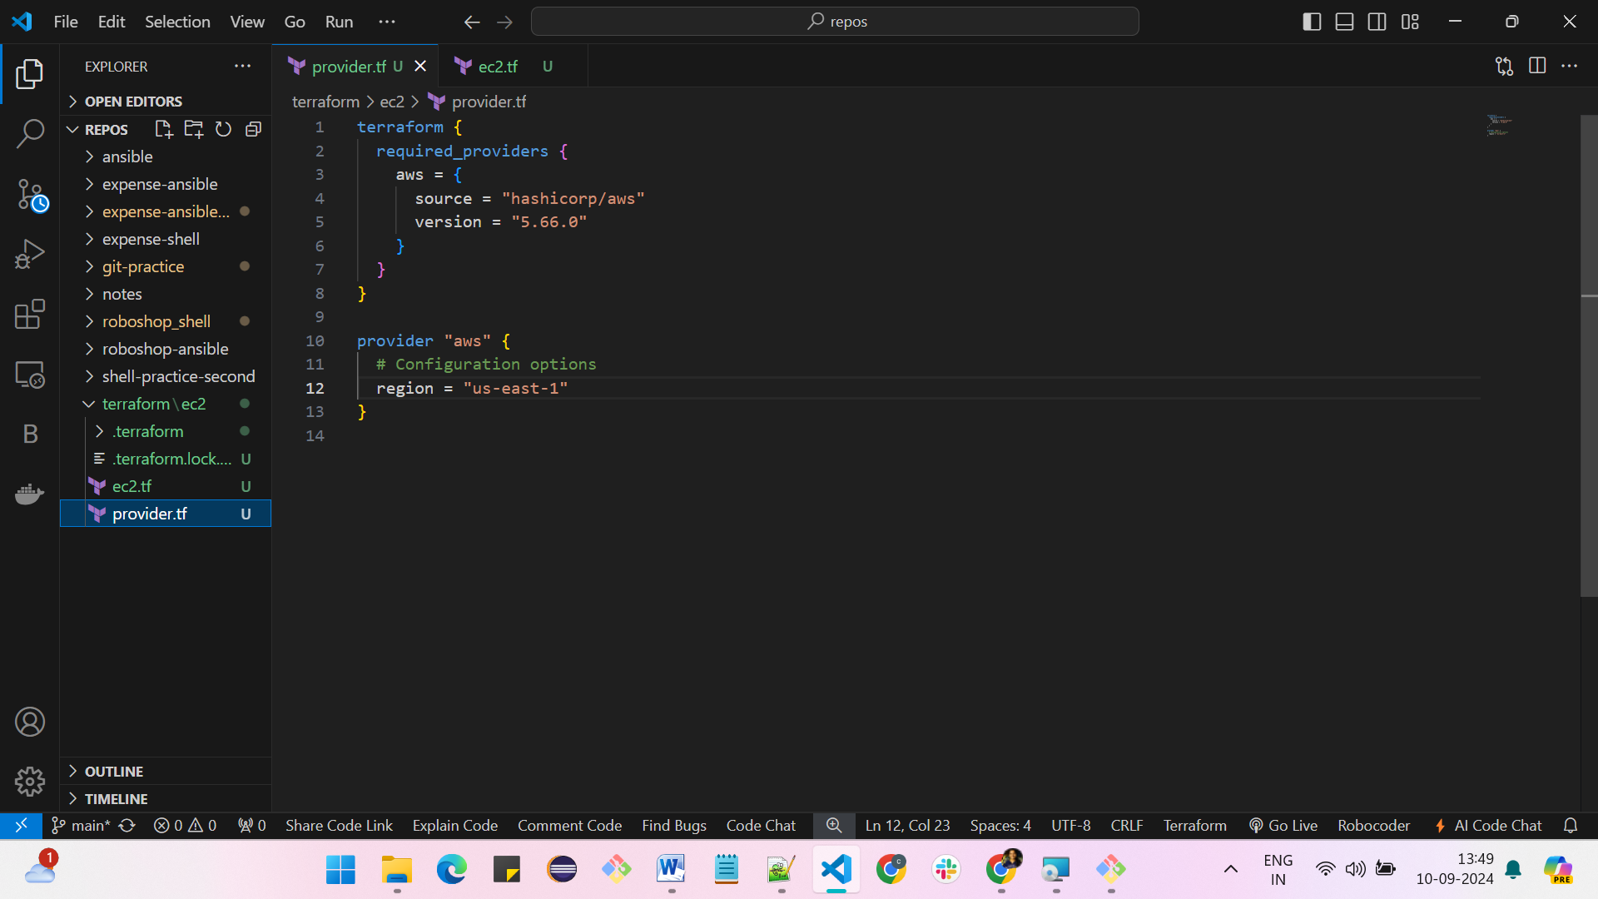

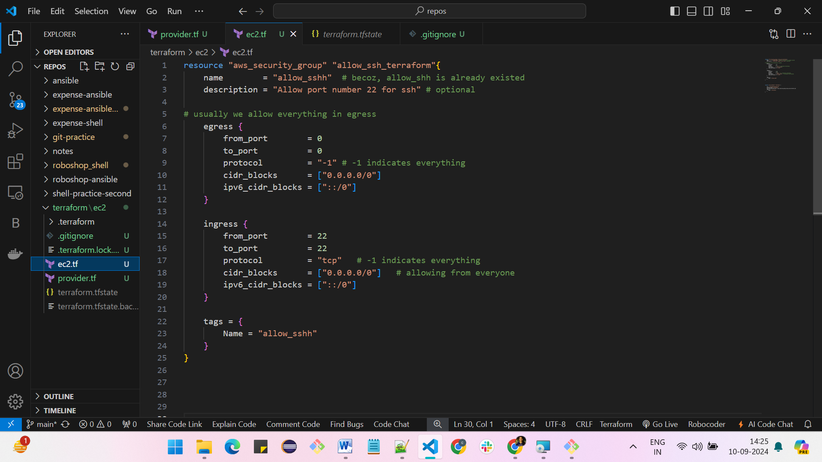

**terraform init -> To initiate the terraform**

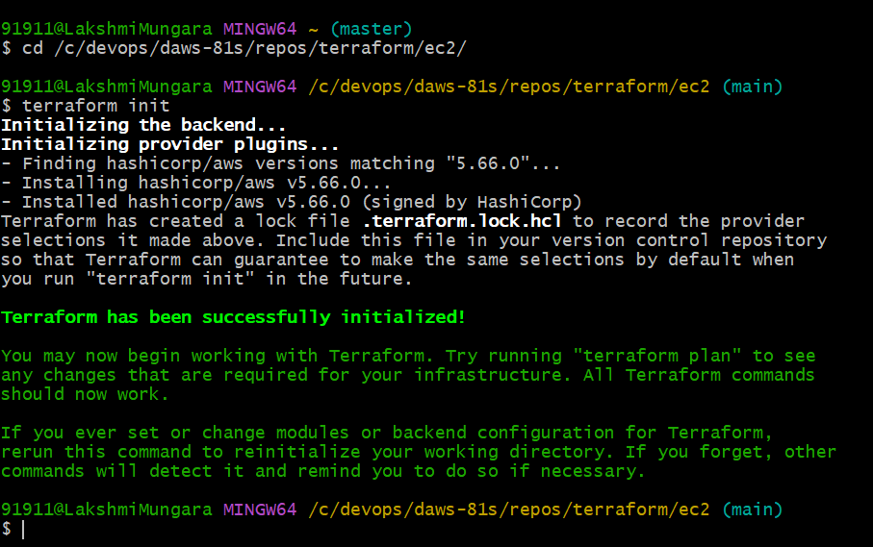

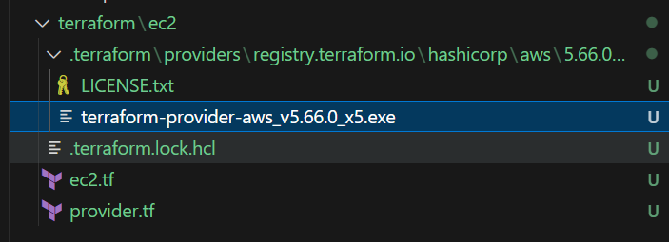

**terraform plan -> It checks the syntax and contents and gives what it can do**

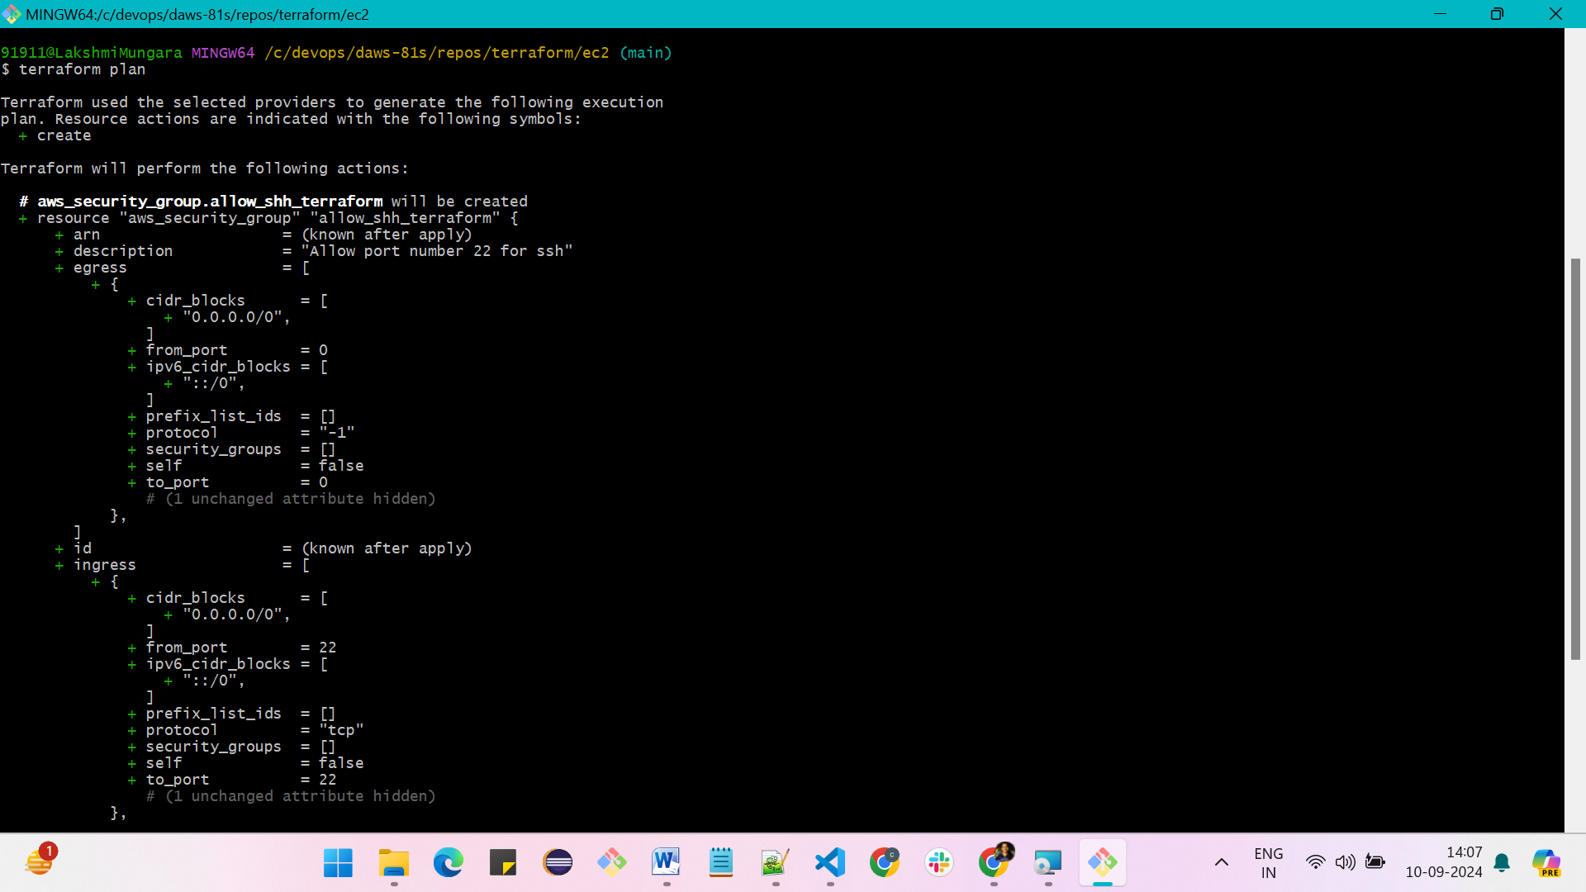

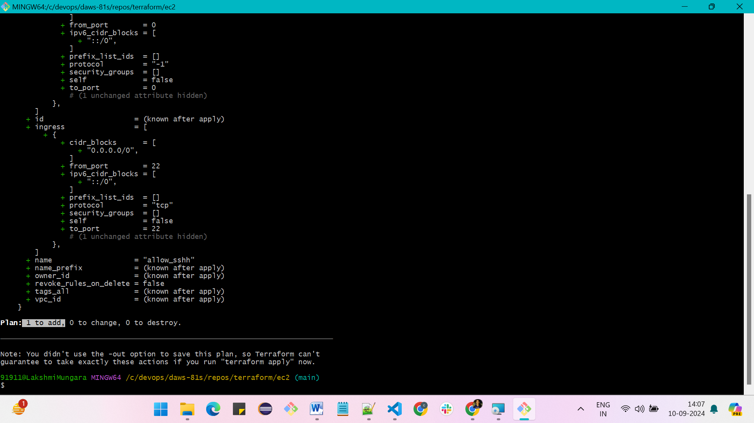

**terraform apply Or terraform apply –auto-approve -> which executes the action proposed by terraform plan**

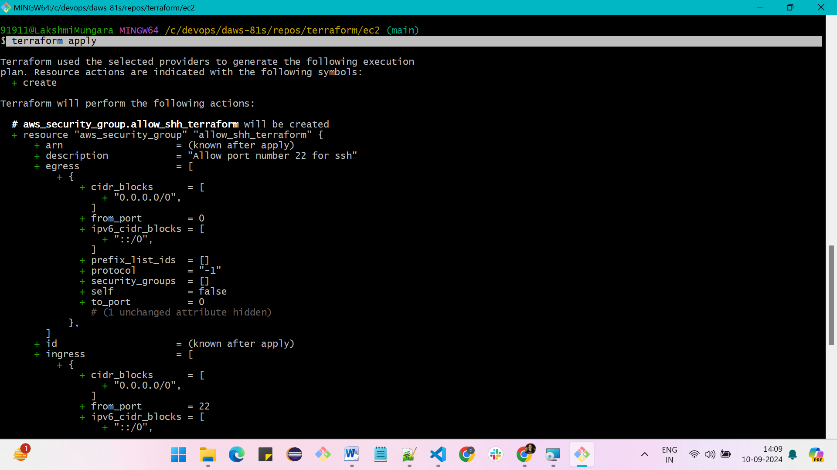

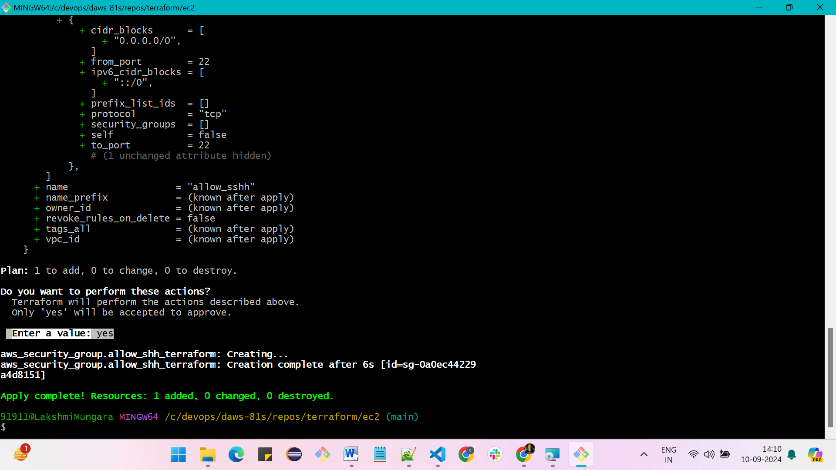

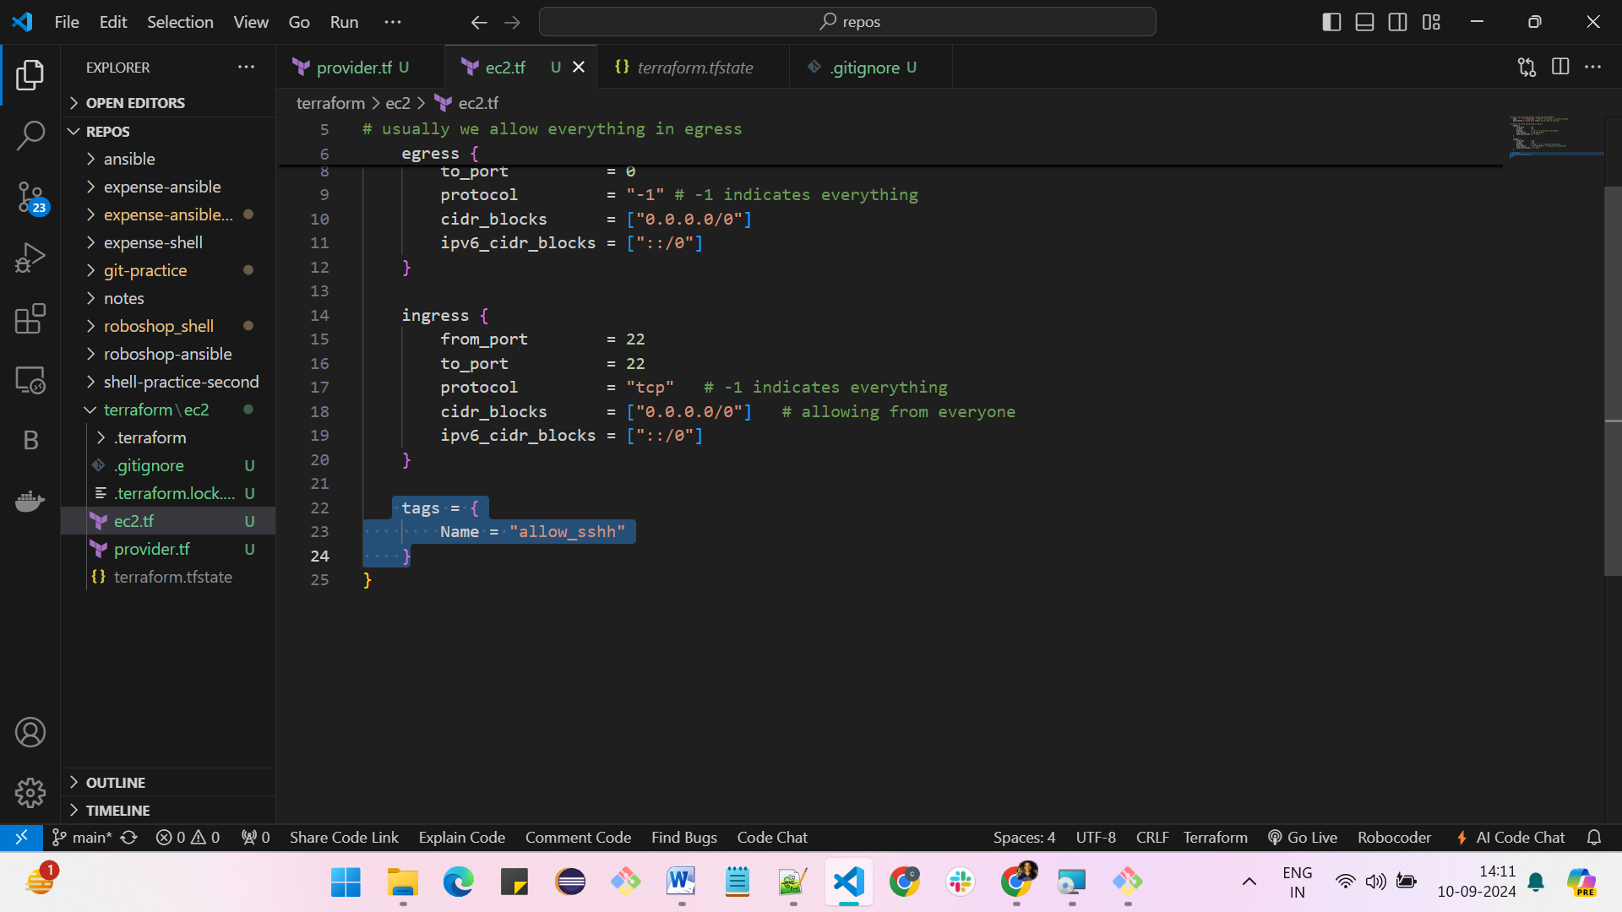

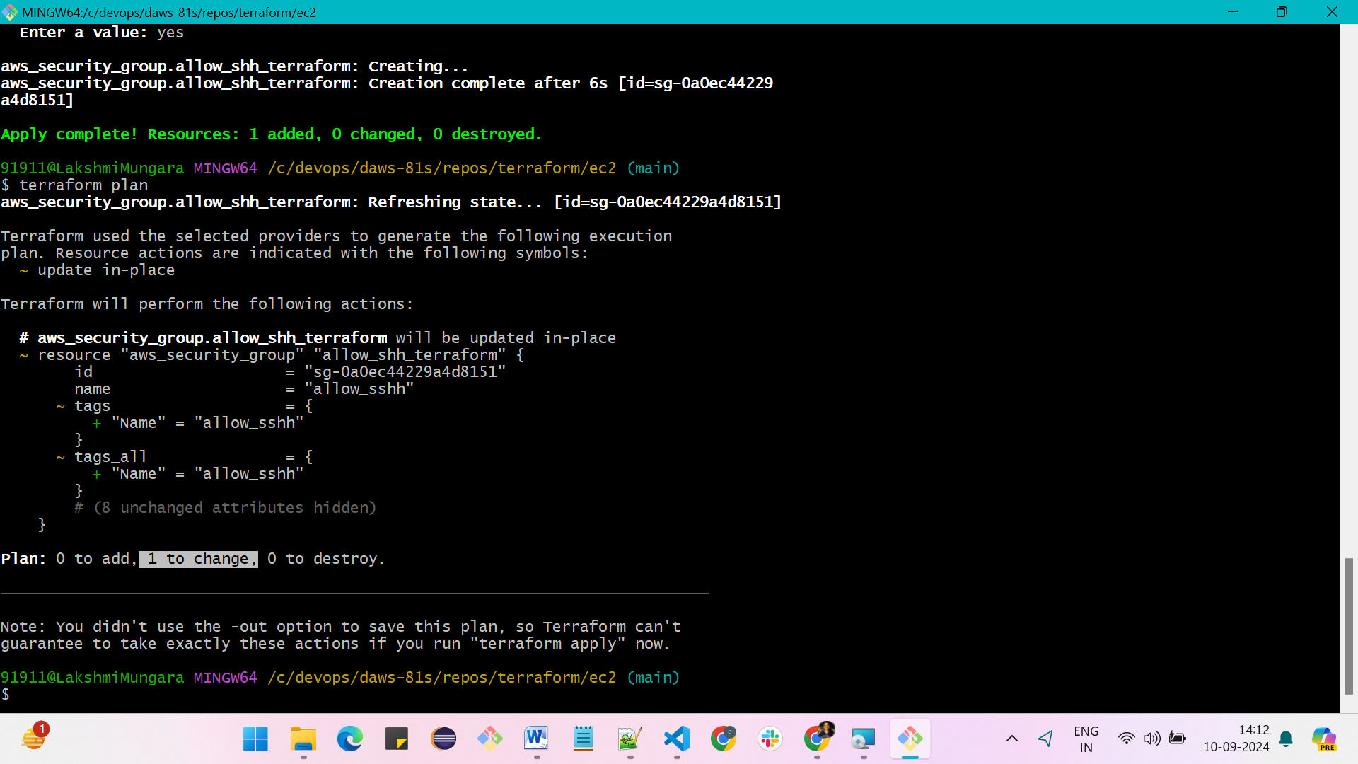

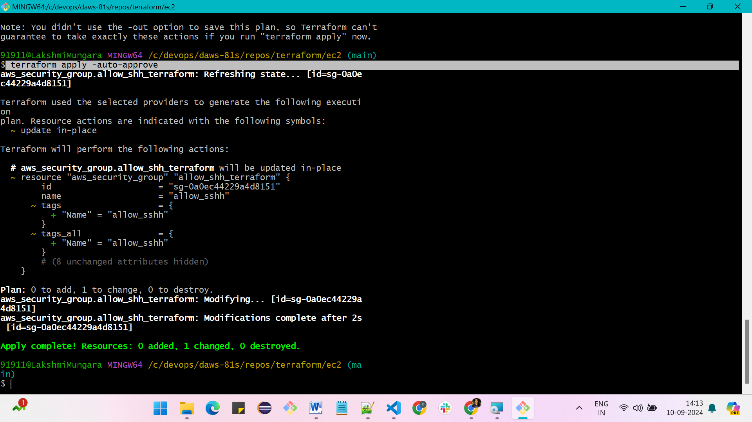

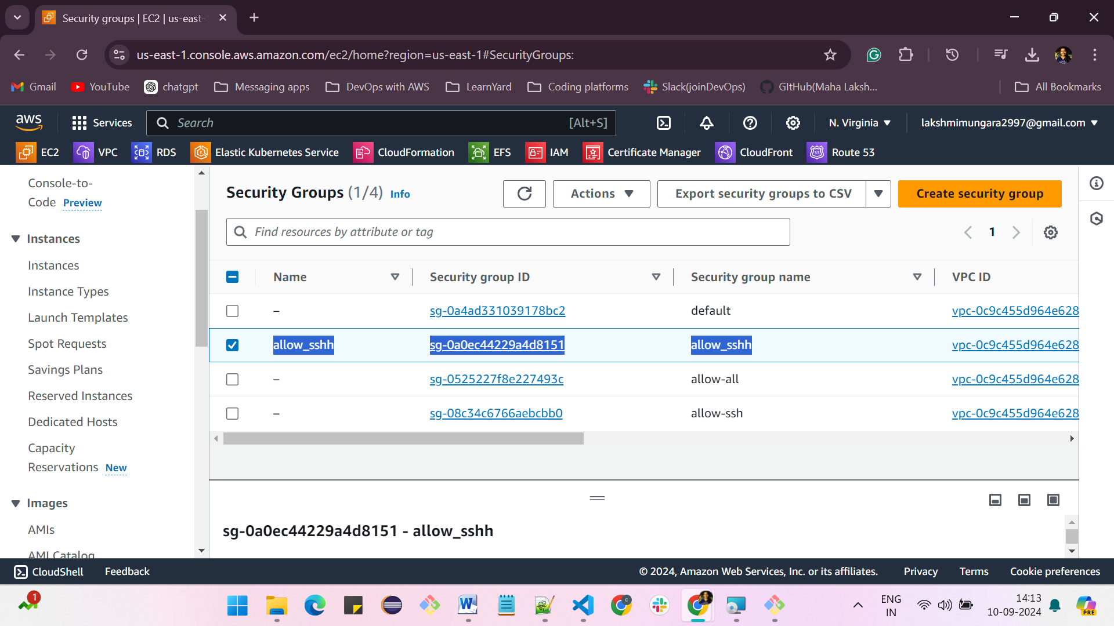

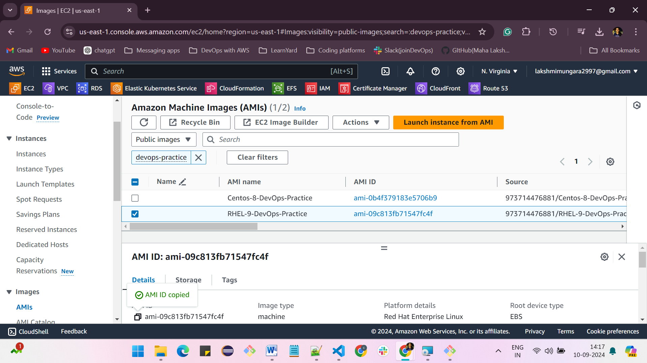

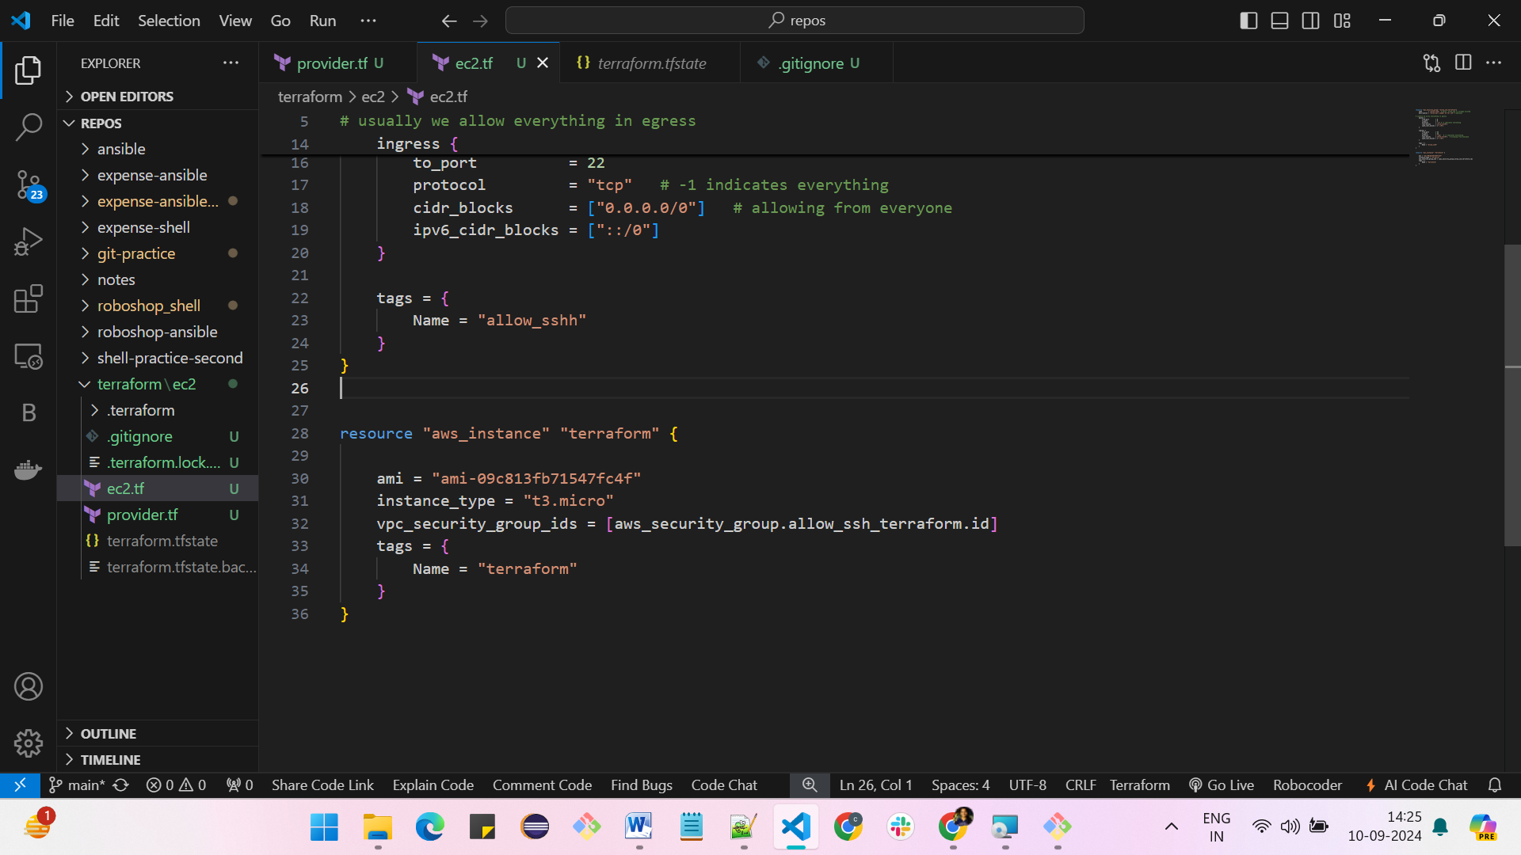

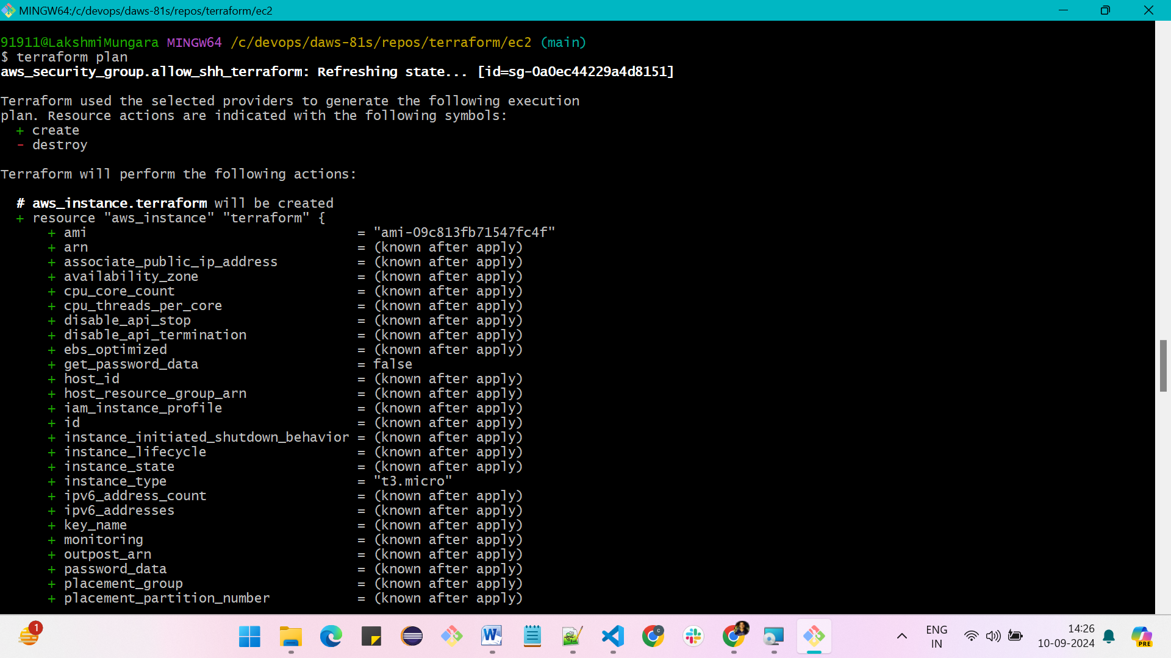

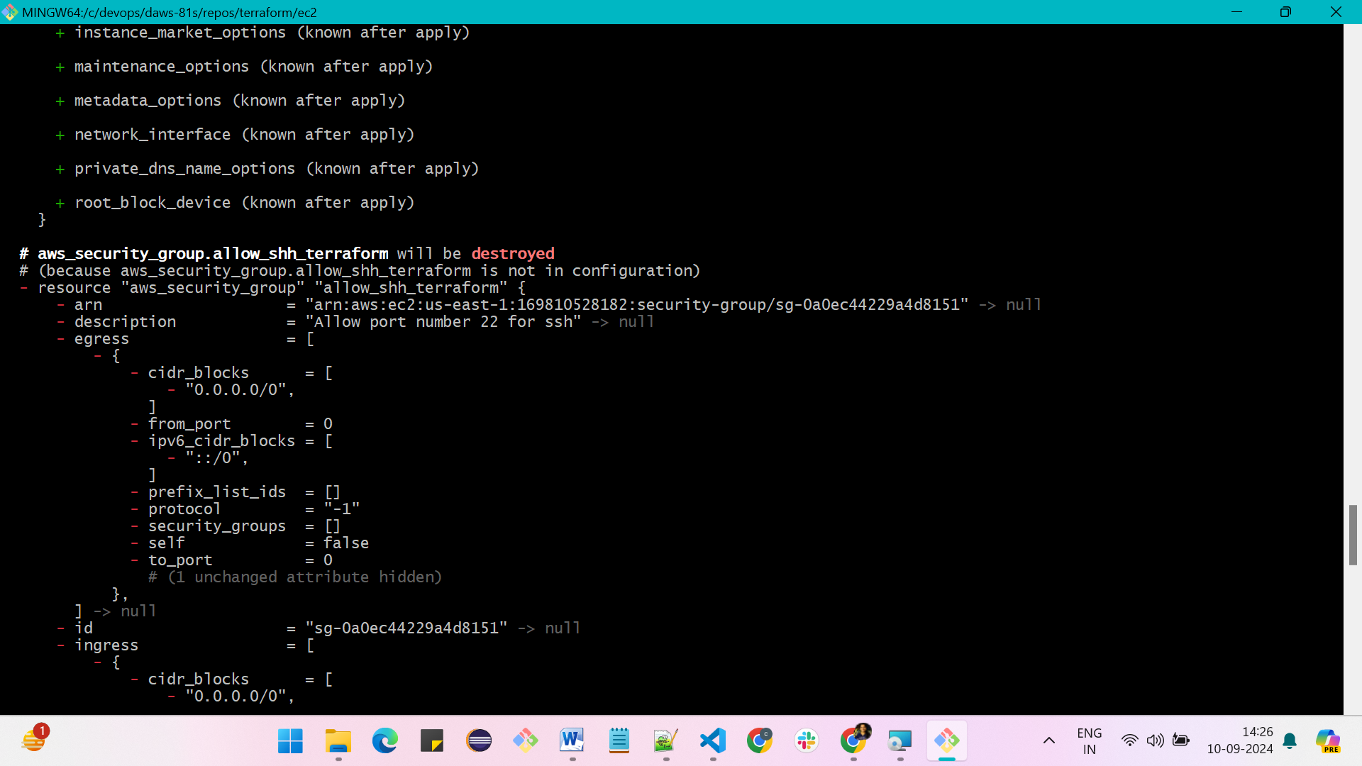

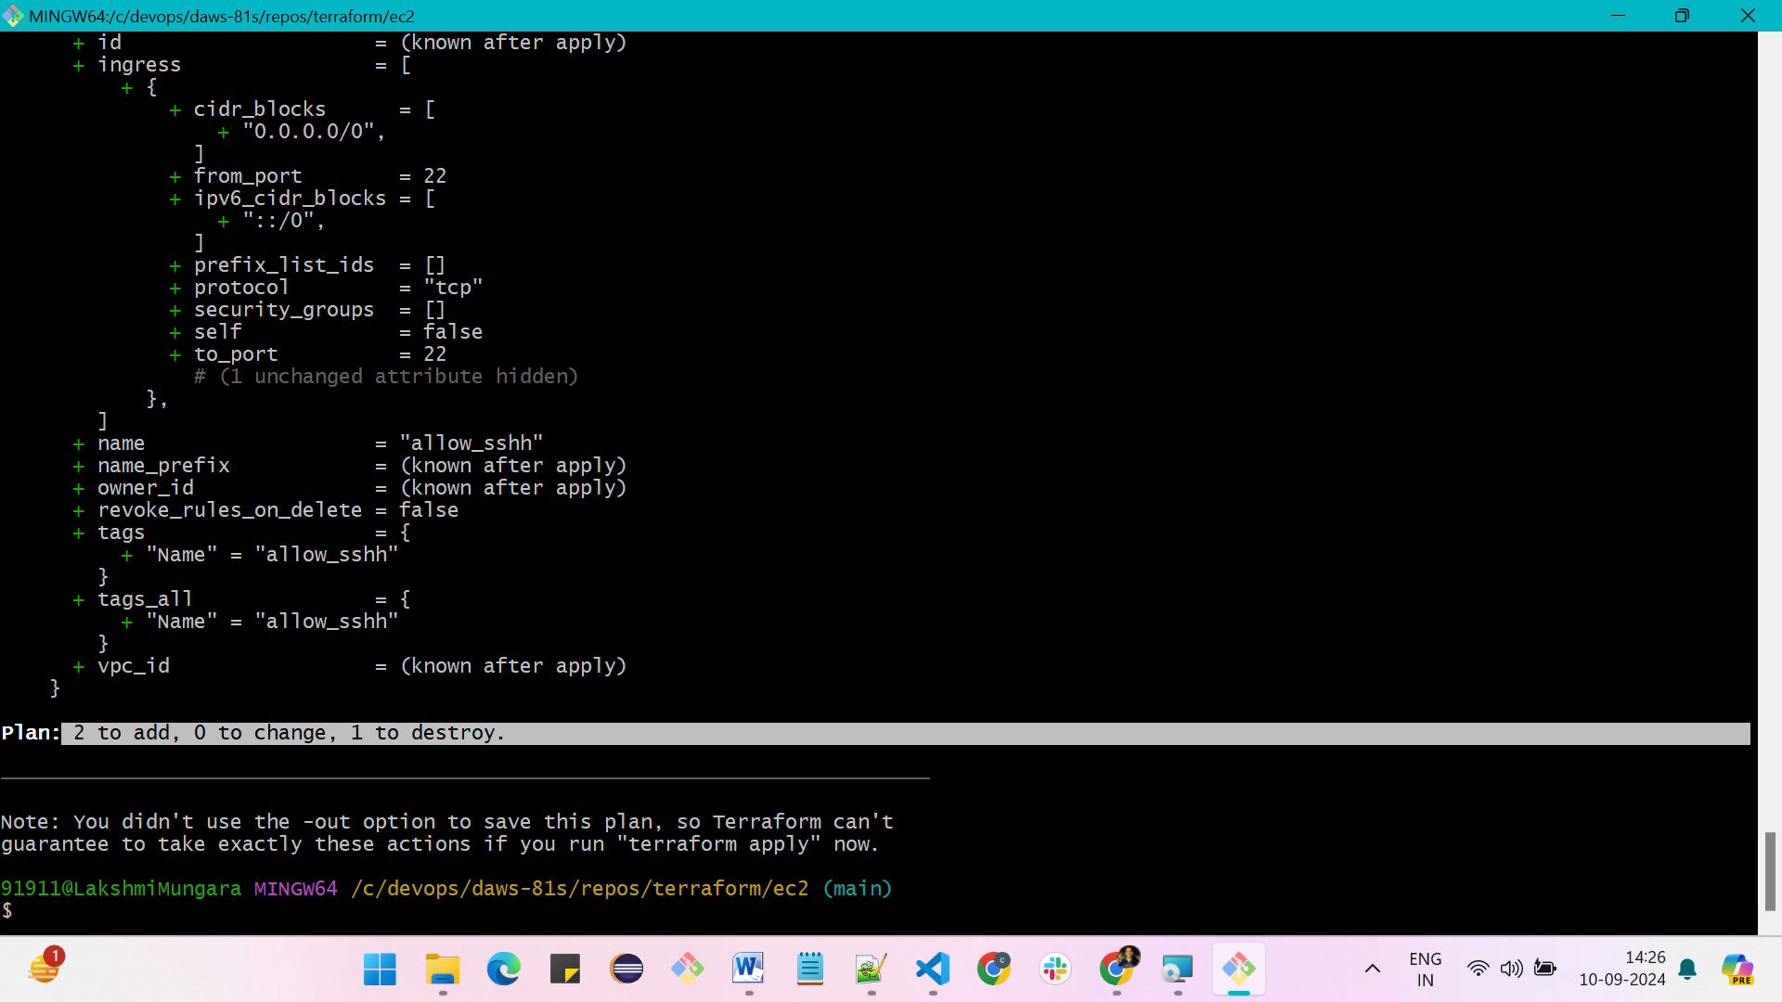

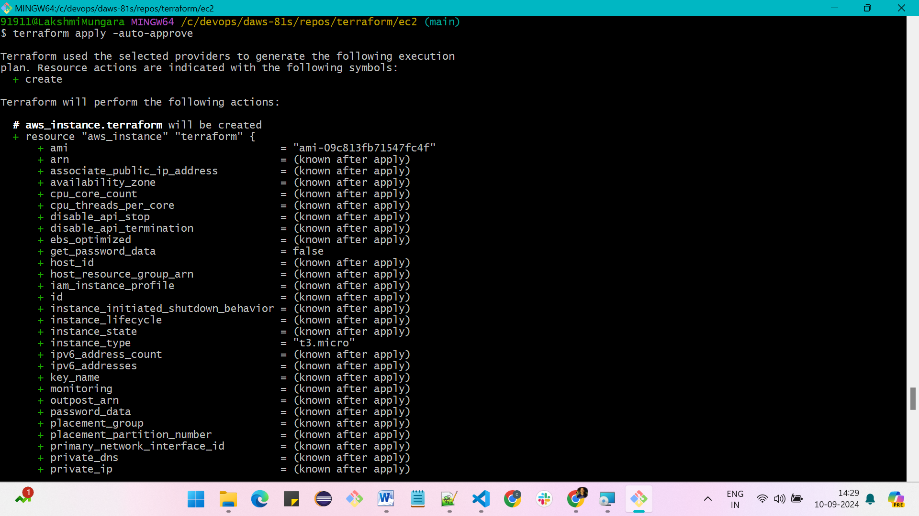

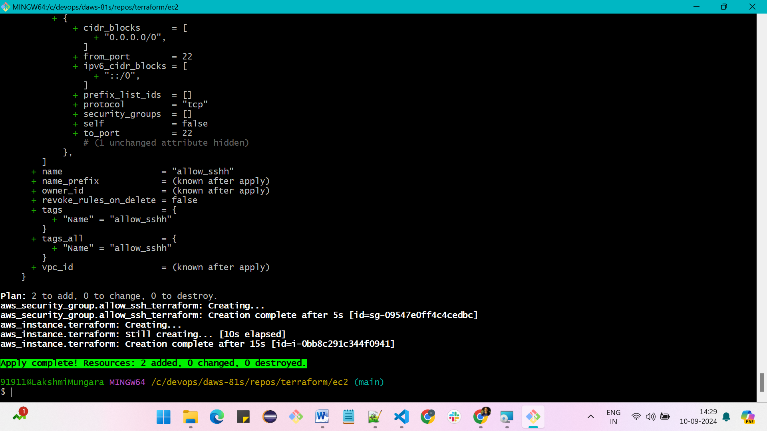

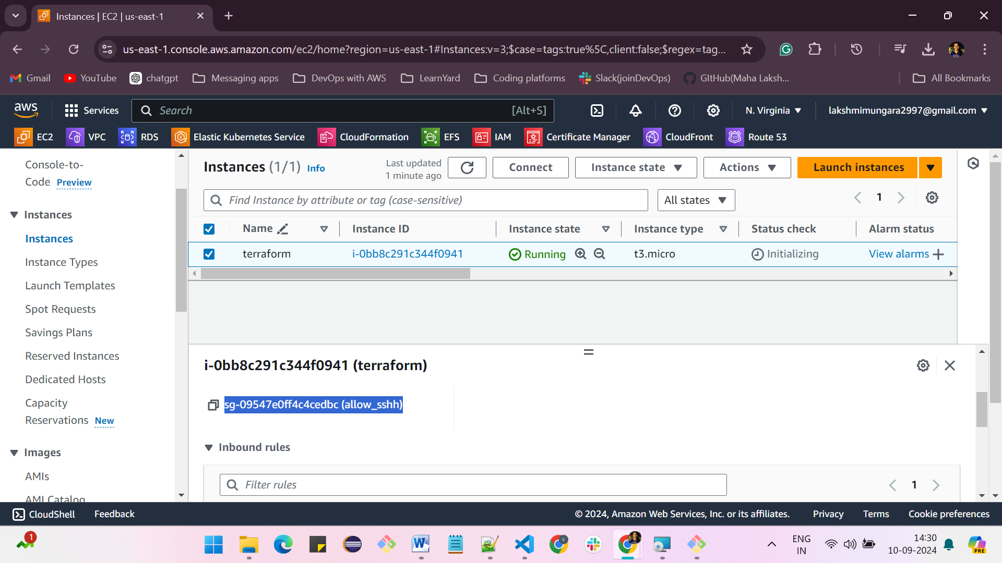

**To destroy the instances after completion of practice**

**Command is, terraform destroy –auto-approve**

**First, it destroys the instances which is dependent on security group**

**And then security group**

